R- Programming

EXPERIMENT-1 Addition
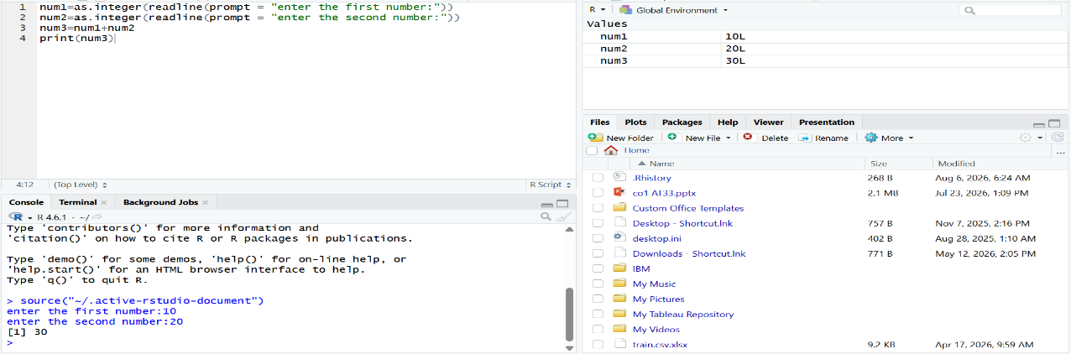

EXPERIMENT-2 Subtraction
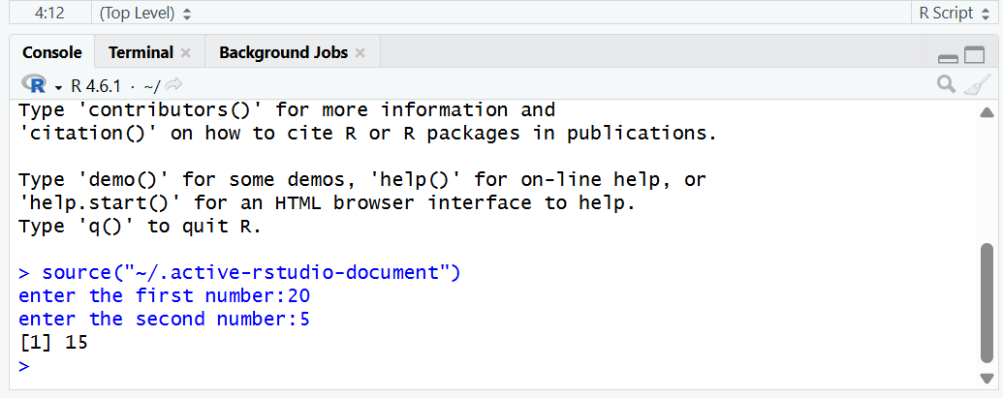

EXPERIMENT-3 Multiplication
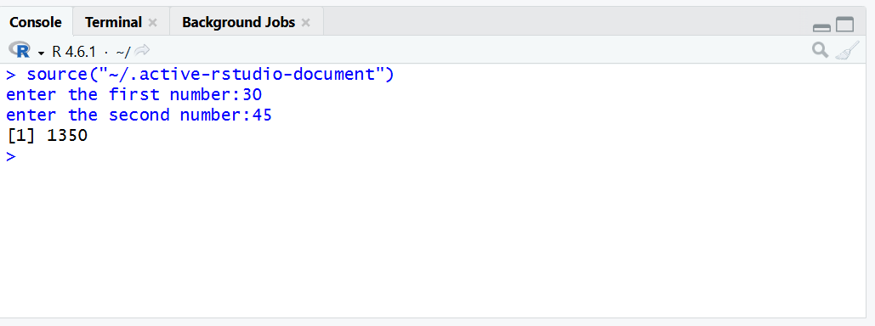

EXPERIMENT-4 Division
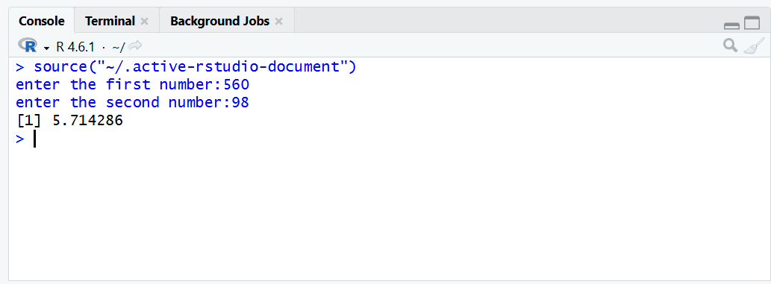

EXPERIMENT-5 Odd or Even

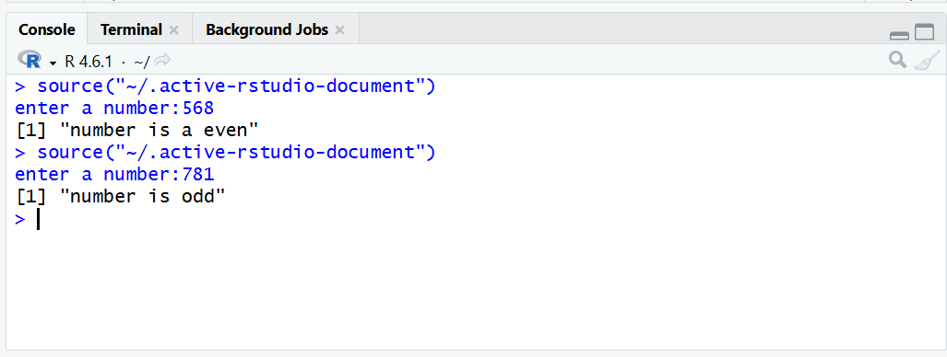
EXPERIMENT-6 Mean, Median, Mode

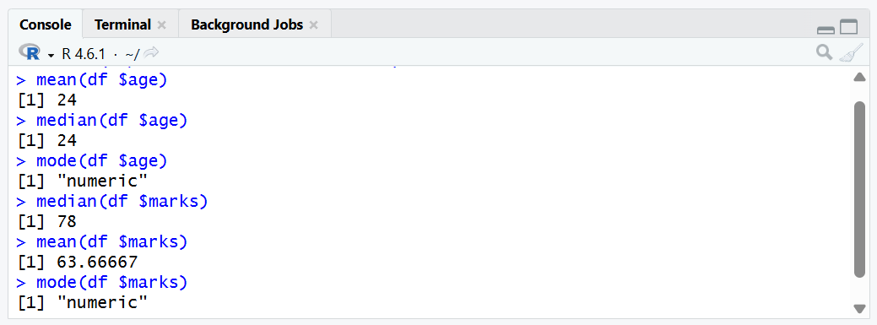
EXPERIMENT-7 Summary

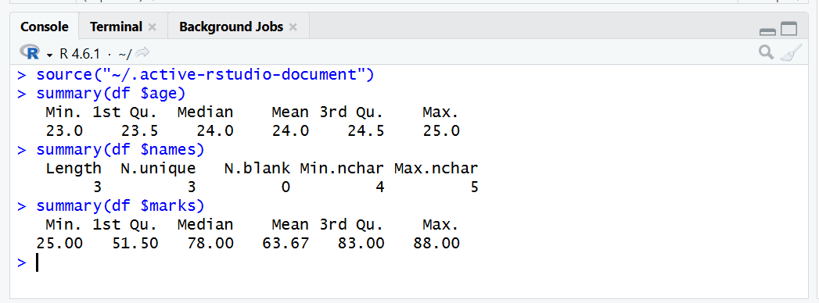
EXPERIMENT-8 Greater Among Three numbers

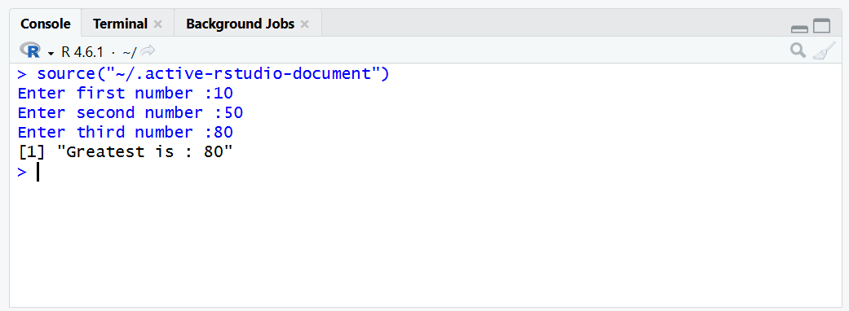
EXPERIMENT-9 IQR

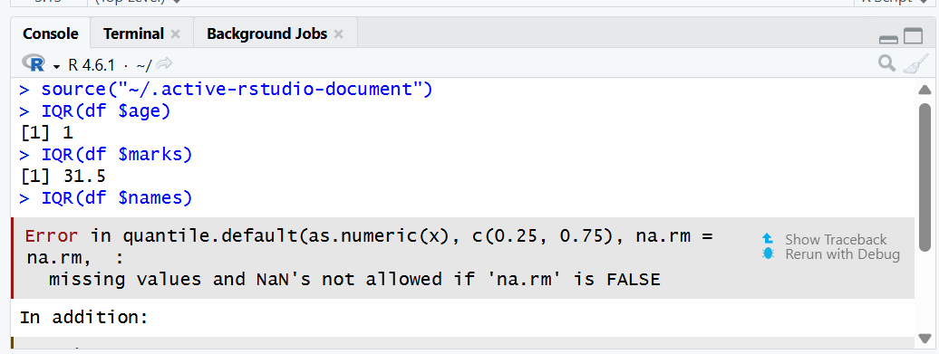

EXPERIMENT-10 Quantile

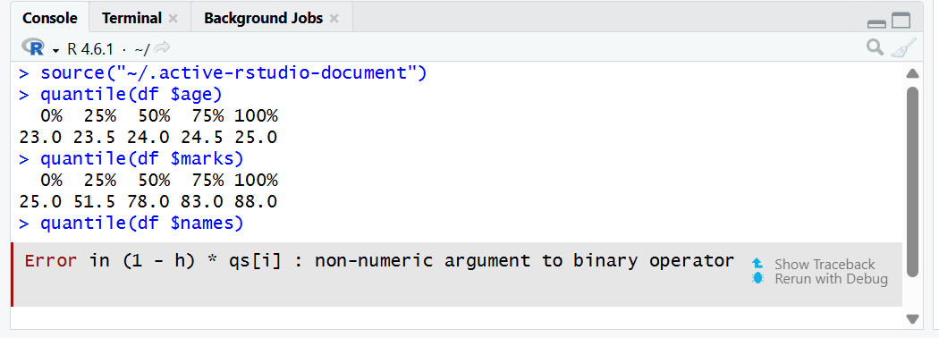

EXPERIMENT-11 Mid Range
Age:
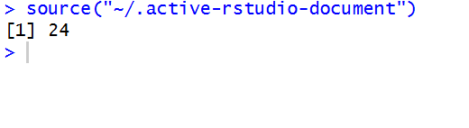
Marks:
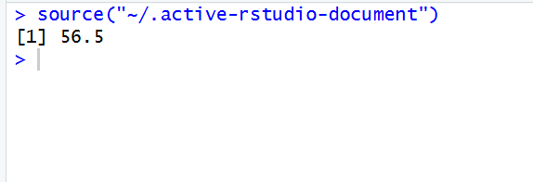
Names:
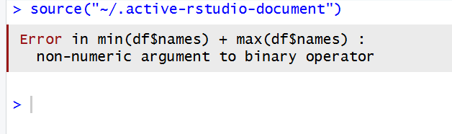

EXPERIMENT-12 Z- Score Normalization

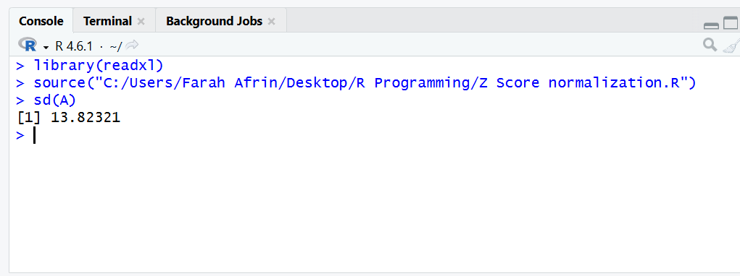

EXPERIMENT-13 Min, Max, Mean, Min-Max
Mean:
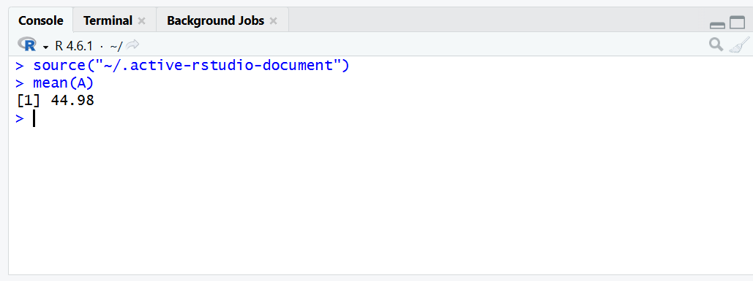

Minimum:
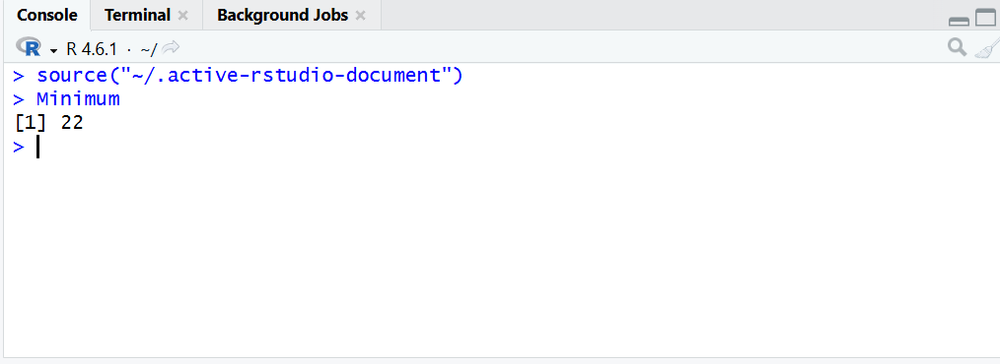
Maximum:
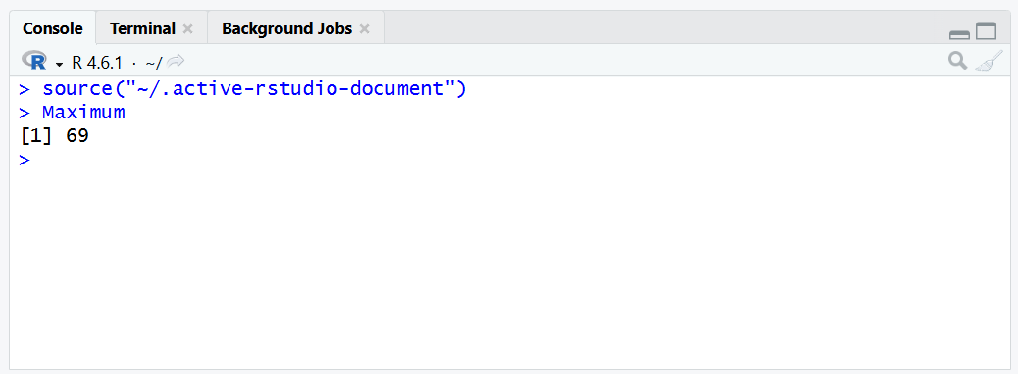

Min - Max
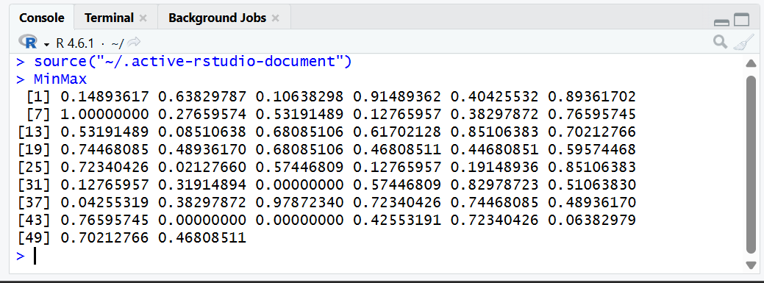
EXPERIMENT-14 Bar Plot and Horizontal Plot

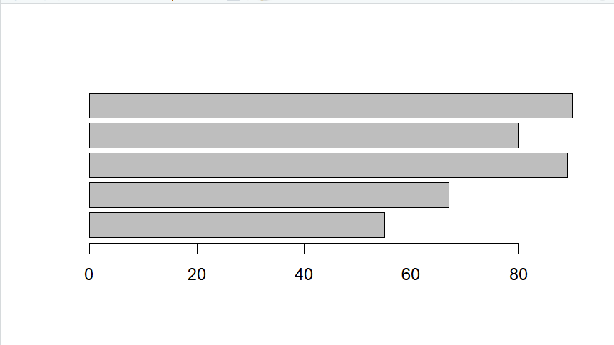
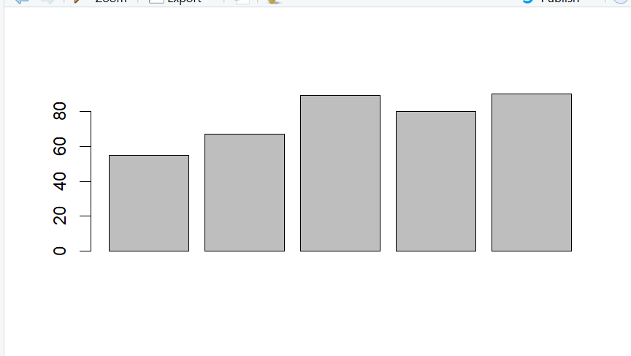
EXPERIMENT-15 Box Plot
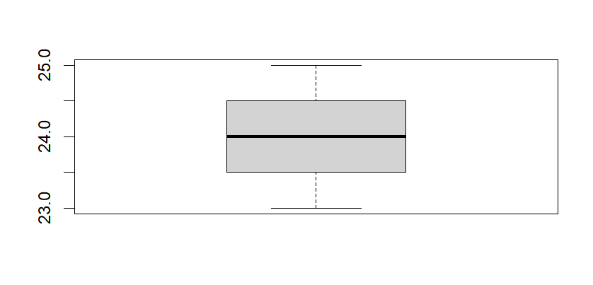

EXPERIMENT-16 Histogram
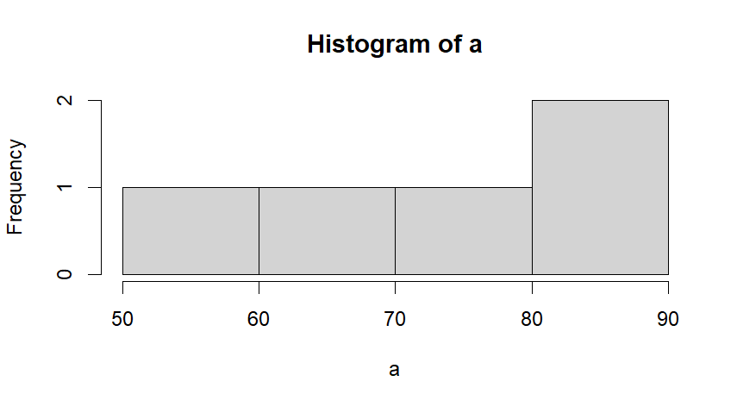 EXPERIMENT-17 Correlation Analysis

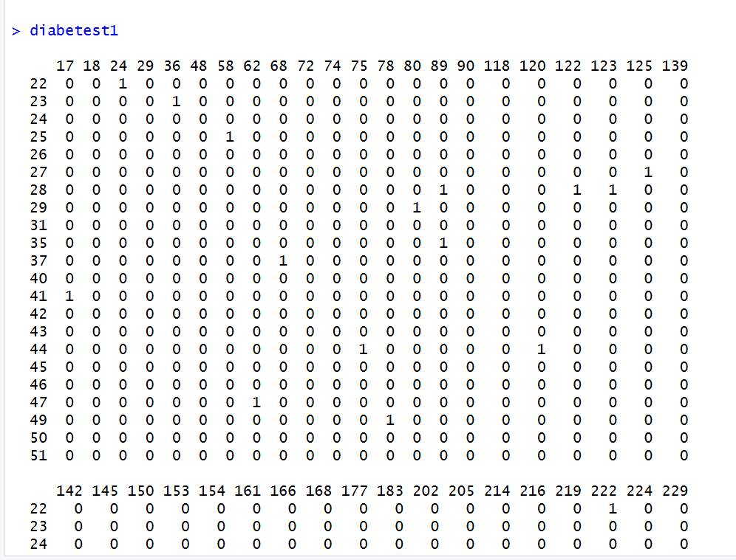

EXPERIMENT-18 Scatter Plot

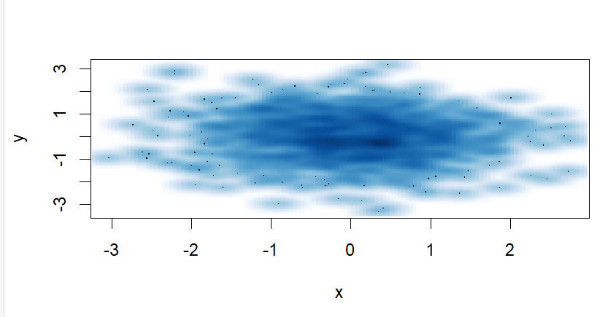 EXPERIMENT-19 Linear Regression Analysis
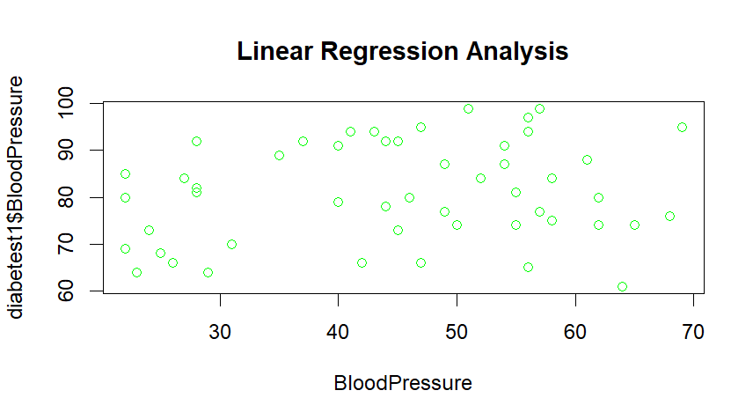

EXPERIMENT-20 Multiple Regression
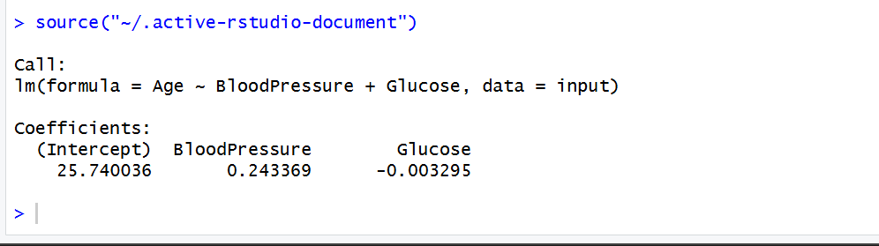
print(model):
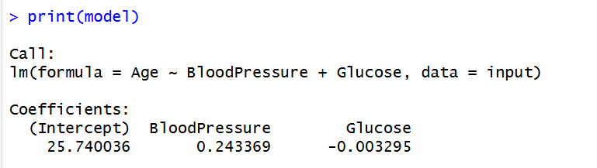
A <- coef(model)[1]
print(A)
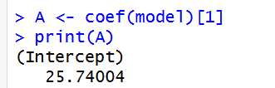
coef(model)
